Steps to Edit the Task

1. View.component.TS:

Added new method as EditTask and passed the task that is being selected for edit.

Router call to call the Update Component.

Note: this works fine because the console.log prints the name that I select

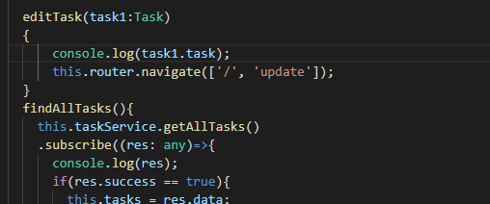

Viewcomponent.html

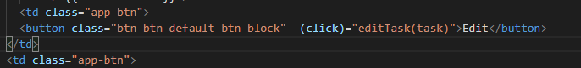

My thought was to pass the selected task as object from View component to Update Component and then bind the object. So that any update, we make will be in the task object that can be sent in the update method to the server

I am stuck how to pass the task object named “task1” . I tried with @input so that it can be accessed in update component and assigned to local task object that is binded in html.

I am not able to receive the task1 object from View to update component. Please help

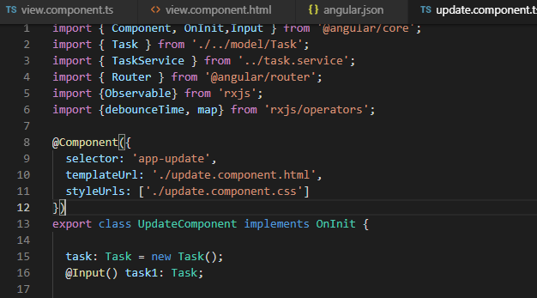

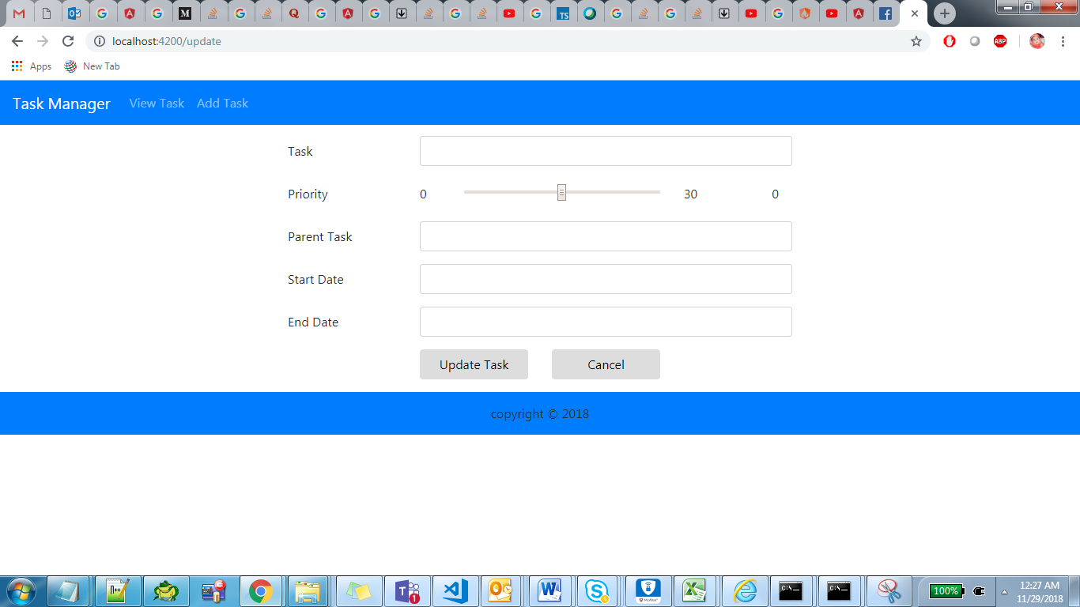

I am expecting to populate the values what I am passing from View component so that I can update and save.